Hello JANESCRIPT

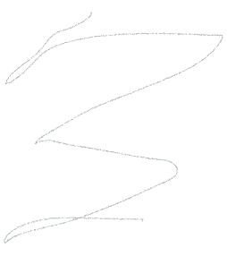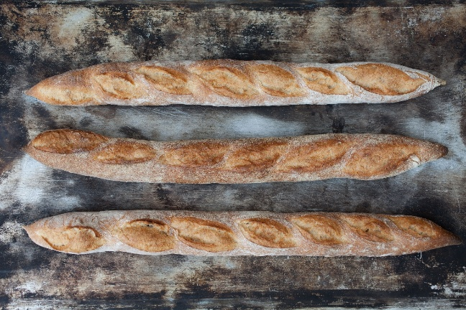

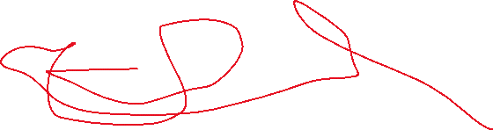

|  |  |  |  |
| --- | --- | --- | --- |
| Stampede | £$£$ |  |  |
| 1+4+5 |  |  |  |
|  |  |  | Plo koon |

